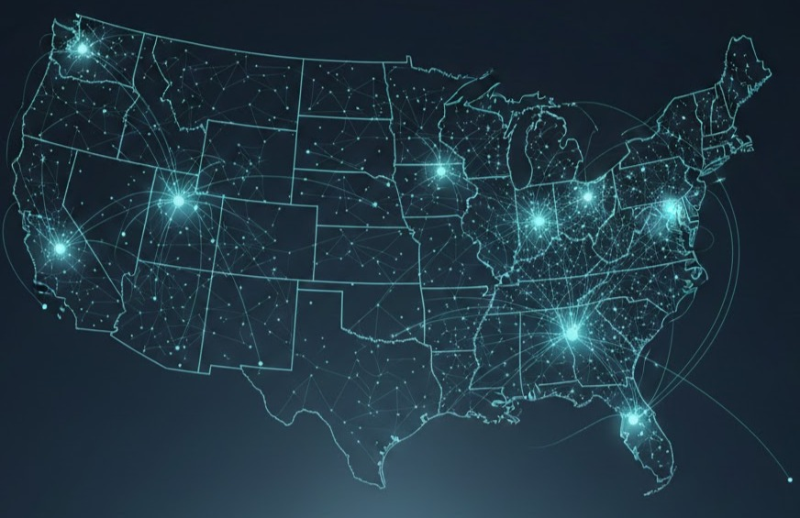
Stability Capitalism
A Framework for AI Transition Economics
REnee K. McInerney
MacAisling Corp.
version 2.0 December 2025
Working paper

Document History

Version | Date | Changes
1.0 | Nov 25, 2025 | Initial public release
1.1  2.0 | Nov 26, 2025  Dec 17, 2025 | Clarified per-individual eligibility and recipient categories. Corrected margin terminology (30–40% = operating margins). Added title to Global Effects table. Added Appendix N: Cloud Provider Margin Analysis. Removed redundant APA bibliography (citations available in Appendix O)  Major update to reflect new modeling.

Table of Contents
Document History 2
0.0 Executive Summary 5
1.0 Current Displacement Patterns 7
1.1 Velocity Mismatch 8
1.2 Structural Constraints on Retraining 8
1.3 Capital Reallocation Patterns 9
2.0 The Collection Mechanism 12
2.1 Distribution Phasing 15
2.2 Benefit Structure 16
2.3 Responsive Delivery 21
2.4 Ethical Principles 22
2.5 Programs Stability Capitalism Replaces or Makes Obsolete 22
2.6 What Stability Capitalism Unlocks 22
2.7 Macro-Level Outcomes Stability Capitalism Produces 23
2.8 Administrative Simplicity and Implementation Efficiency 24
3.0 The Architecture of Stability Capitalism 24
3.1 Overview of the Two-Fund Model 24
3.2 20-year glide path to Single Funded Stability Capitalism 25
3.3 Fertility Impact 25
3.4 Inflation Adjustment (COLA): How the AI Dividend Stays Stable 25
4.0 Real Estate Inflation 26
5.0 Global Impacts 28
6.0 The Ten Biggest Objections and Myths 29
Appendix A: Technical Architecture - Token-Based Collection and Distribution System 31
Appendix B: UBI vs. Stability Capitalism 37
Appendix C: Potential Savings from Program Consolidation 38
Appendix D: Ohio Pilot Program - Suggested 39
Appendix E: Top 20 Jobs & Pay Estimates Under Stability Capitalism 42
Appendix F: Frequently Asked Questions 44
Appendix G: Stability Capitalism, Simple Breakdown (For Regular People) 50
Appendix H: Glossary & Technical Definitions 51
Appendix I: Modeling Assumptions 52
Appendix J: Inference Methodology & Revenue Projections 53
Appendix K: Birth-Rate Evidence & Fertility Literature Review 56
Appendix L: Cloud Provider Margin Analysis 58
Appendix M: Full List of References for "Stability Capitalism" 59

Executive Summary
Artificial intelligence systems are reshaping labor markets at an accelerating pace. Across healthcare, finance, retail, logistics, and technology sectors, organizations are consolidating or eliminating roles previously performed by skilled workers. These shifts are observable in employment data, corporate earnings reports, workforce announcements, and longitudinal reclassification of roles within firms. Mid-career workers, particularly those aged 45 and older, face disproportionate displacement during peak earning years, with limited pathways to comparable positions.
Existing policy mechanisms were not designed for this velocity of change. Retraining programs operate on multi-year timelines while displacement occurs in quarters. Unemployment insurance assumes re-employment into similar roles. Universal basic income proposals, in their pure form, face political resistance due to perceived work disincentives and deficit concerns. Corporate voluntary initiatives have not demonstrated scale. Collectively, these mechanisms assume gradual disruption, sectoral isolation, and individual retraining as the primary adjustment lever; assumptions that no longer hold under AI-driven productivity scaling.
This paper explores Stability Capitalism, a framework for distributing AI-generated productivity gains through a micro-fee on commercial AI inference. The mechanism is structurally similar to the Alaska Permanent Fund, substituting AI compute for oil extraction as the revenue base.
The Core Mechanism
A token-based fee of $0.0009 per commercial AI inference, approximately one-tenth of one cent, is collected at cloud API endpoints, infrastructure that already exists for billing purposes. Fees flow to a sovereign fund, which distributes monthly AI Dividends (an AI-Funded stability dividend) while investing surplus for expansion.
The fee is economically marginal relative to cloud provider margins (55–68% gross). At $1,000 in monthly AI compute, the fee adds less than $1. This assumes partial pass-through at most; full pass-through effects are addressed in the economic sensitivity appendix.
Phased Implementation
Year 1 targets individuals earning under $50,000 annually, with surplus revenue building the sovereign fund. Years 2–3 expand the income band as the fund grows. By years 3–4, contingent on sustained inference growth, the fee may reduce to $0.00054 per inference while extending coverage to individuals earning up to $120,000. Households with combined income exceeding $250,000 are ineligible.
Benefit Structure
The AI Dividend launches at $2,000/month for individuals earning under $50,000, and scales to the full $3,000/month psychological-safety threshold by Year 4 as coverage expands and inference volume matures.
Eligible adults receive a monthly AI Dividend establishing a $3,000 income floor at full maturity. Social Security recipients receiving less than $3,000 monthly receive a supplement to reach the floor. No existing benefits are reduced. The AI Dividend functions as an income floor supplement, preserving existing social insurance structures.
AI Dividends are calculated on individual income, with no household linking, providing an escape clause in abusive situations and preserving personal sovereignty. The AI Dividend phases out gradually above income thresholds, avoiding benefit cliffs.
Revenue Projections
Under moderate assumptions (300–500 billion daily commercial inferences at launch in 2027, 30–40% compound annual growth), the mechanism achieves full funding coverage ($3,000 monthly floor for up to 100 million adults) within a decade. Conservative scenarios extend the timeline; aggressive adoption accelerates it. Detailed sensitivity analyses across volume, growth, and phasing scenarios are presented in the technical appendix.
Collection Architecture
The system leverages existing cloud provider metering infrastructure, adding multi-party validation and blockchain settlement for transparency. This minimizes administrative overhead, prevents under-reporting through cross-validation, and creates an immutable audit trail. Alternative architectures are discussed for jurisdictions where distributed ledgers are not legally recognized.
Recipients access funds through individual wallets with self-custody options—preventing arbitrary benefit termination and protecting individuals in abusive situations.
Scope and Limitations
This paper presents one possible framework for addressing AI-driven labor market transitions. It does not claim to be the only viable approach, nor does it resolve all implementation challenges. The framework is intended as a complement to, not a substitute for, broader labor market reforms. Open questions remain regarding international coordination, inflation effects, and political feasibility.
The analysis that follows examines observed labor market conditions, evaluates why existing mechanisms face structural constraints, details the Stability Capitalism model, and presents implementation scenarios with associated uncertainties.

1.0 Current Displacement Patterns
Through November 2025, U.S. employers announced 1.17 million job cuts, a 54% increase over the same period in 2024 and the highest year-to-date total since 2020. October alone saw 153,000 announced cuts, the worst October for layoffs since 2003. The last time annual layoff totals reached comparable levels was 2008, during the financial crisis.
The distribution of cuts reveals a structural pattern. Government agencies account for the largest share of announced eliminations—over 307,000—followed by the technology sector at approximately 153,000. Major employers including UPS (48,000), Amazon (30,000), Intel (24,000), Ford (11,000), and Microsoft (7,000) have announced significant workforce reductions. These are not predominantly entry-level positions. They are skilled, mid-career roles that historically formed the foundation of middle-class economic stability.
Workers aged 45 and older account for an estimated 55% to 65% of layoffs, a marked increase from prior years. This cohort faces disproportionate displacement during peak earning years, with limited pathways to comparable positions. Only 40% to 50% of laid-off workers return to jobs with similar compensation; the remainder accept cuts of 10% to 20% or exit the workforce entirely.
Long-term unemployment is rising beneath surface-level indicators. One in four unemployed Americans, approximately 1.8 million people, has been out of work for more than six months. When benefits expire, many fall out of official counts, masking the depth of labor market stress.
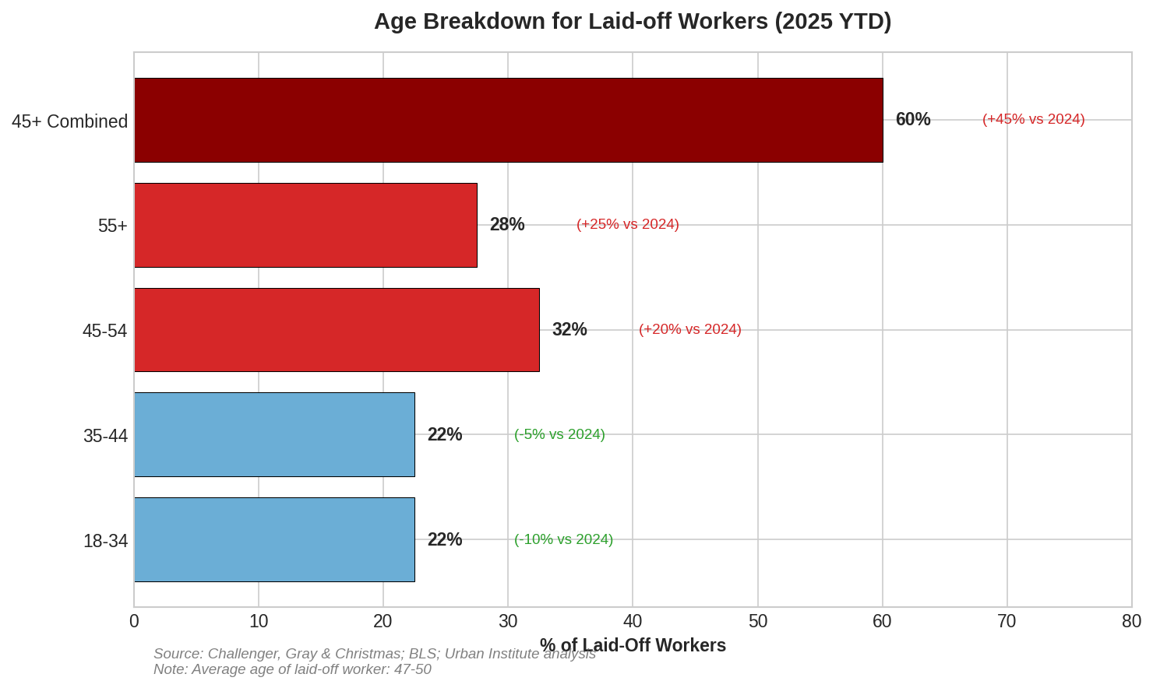
Figure 1 Age Breakdown for Laid-off Workers (2025 YTD)
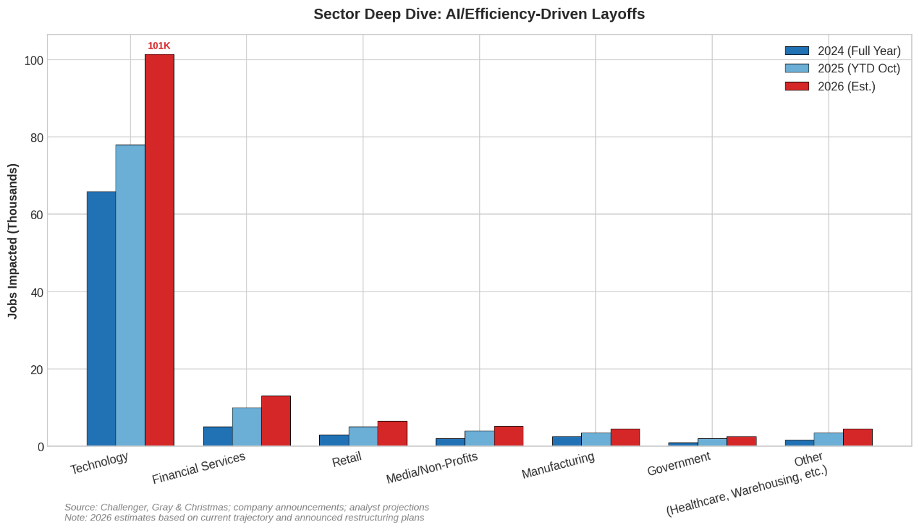
Figure 2 Sector Deep Dive: AI/Efficiency Driven Layoffs (2024 vs. 2025, 2026 Est.)

Velocity Mismatch
Between 2023 and 2025, artificial intelligence adoption followed an exponential curve rather than the gradual trajectory policymakers anticipated. Capabilities that were expected to emerge over a decade arrived in less than two years. Systems that drafted simple correspondence in 2023 now generate software architectures, manage customer service operations, process legal documents, and automate complex analytical workflows.
For the first time in modern U.S. history, productivity gains are appearing at scale before displaced workers can be reabsorbed into the labor market. The institutions designed to manage labor transitions were built for a different pattern: temporary downturns followed by recovery into similar roles. Unemployment insurance assumes re-employment within months. Retraining programs assume destination jobs exist upon completion. Social Security assumes a stable tax base of contributing workers.
These assumptions no longer hold under conditions of rapid, AI-driven displacement. When roles are eliminated through automation, existing mechanisms do not fill the income gap quickly enough to prevent cascading effects on household stability, healthcare access, and regional economies.

Structural Constraints on Retraining
Mid-career professionals face structural barriers to occupational transition that policy discussions often underestimate. A 50-year-old project manager often cannot feasibly retrain as an electrician or plumber: the physical demands, time to certification (4-5 years for master tradesperson status), and income gap during transition exceed what most households can absorb—while entry-level AI-exposed roles vanish fastest. Savings deplete. Mortgages default. The retraining path itself becomes a source of instability rather than a solution.
The scale of projected displacement compounds this constraint. Estimates from the World Economic Forum's 2025 Future of Jobs Report and McKinsey suggest that 85 to 140 million U.S. jobs may face significant disruption by 2035. Cumulative GDP impact projections from RAND and CBO range from $15 to $30 trillion by 2040. These figures, if realized, would exceed the cumulative economic output losses of the Great Depression, with a critical difference: the effects would unfold over two to three decades rather than concentrating in a single acute crisis.
This distinction matters for policy design. Acute crises generate political momentum for intervention. Chronic, slow-moving displacement disperses harm across time and geography, reducing visibility and urgency while compounding intergenerational effects.
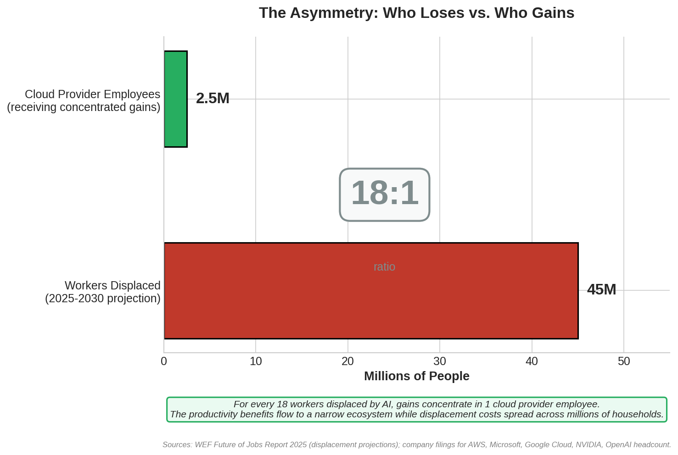
Figure 3 The Asymmetry: Who Loses vs. Who Gains

1.3 Capital Reallocation Patterns
When organizations reduce headcount, associated cost savings reallocate within the corporate structure. For most firms, labor represents 50% to 70% of operating expenses, encompassing salaries, healthcare contributions, retirement matching, paid leave liabilities, training costs, and management overhead. These savings typically flow into retained earnings, shareholder distributions, stock repurchase programs, executive compensation, acquisition reserves, and reinvestment in automation infrastructure.
A secondary pattern has emerged specific to AI-driven displacement. When organizations replace human labor with AI systems, they do not eliminate the underlying cost. They redirect it to ongoing compute consumption. The expenditure shifts from wages paid to workers toward recurring API usage, inference fees, and GPU capacity payments to cloud infrastructure providers.
The flow operates as follows: an organization eliminates analyst positions, then increases spending on inference credits and compute capacity. Cloud and model providers record the corresponding revenue growth. In effect, labor costs migrate from household wages to platform fees paid to providers including AWS, Azure, Google Cloud, NVIDIA, OpenAI, Anthropic, and similar infrastructure companies.
For example, Meta's 2023-2025 efficiency initiatives eliminated approximately 21,000 positions while increasing capital expenditure on AI infrastructure by tens of billions annually, explicitly redirecting labor savings toward data centers and model development.
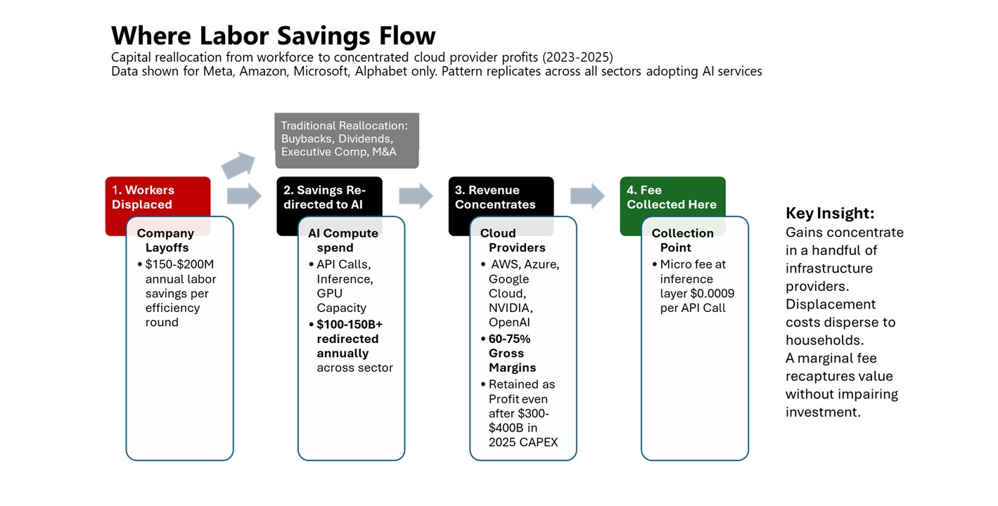
Figure 4 Where labor Savings Flow - capital reallocation from workforce to concentrated cloud provider profits (2023-2025)
Unlike wages, these expenditures enter high-margin cost structures. AWS reports operating margins of 30% to 38%, with analyst estimates placing gross margins at 60% to 68%. Microsoft Cloud reports gross margins of approximately 72%. Crucially, these margins persist even after $300-400 billion in aggregate 2025 capital expenditure across major providers. This margin structure means that a significant portion of redirected labor costs converts to retained profit rather than circulating through the broader economy as wages would.
The pattern creates a structural divergence: productivity gains from AI adoption increasingly concentrate in compute infrastructure providers and adopting firms' balance sheets, while the corresponding displacement costs distribute across affected households, communities, and public support systems.
The data shown above reflects only four major technology firms: Meta, Amazon, Microsoft, and Alphabet. The pattern replicates across all sectors adopting AI services. Healthcare systems, financial institutions, retailers, logistics companies, and government agencies are all paying inference fees to the same concentrated set of cloud providers. When measured economy-wide, Big Tech capex represents approximately 35% of total AI infrastructure spend; the remaining 65% flows from enterprises across every sector.
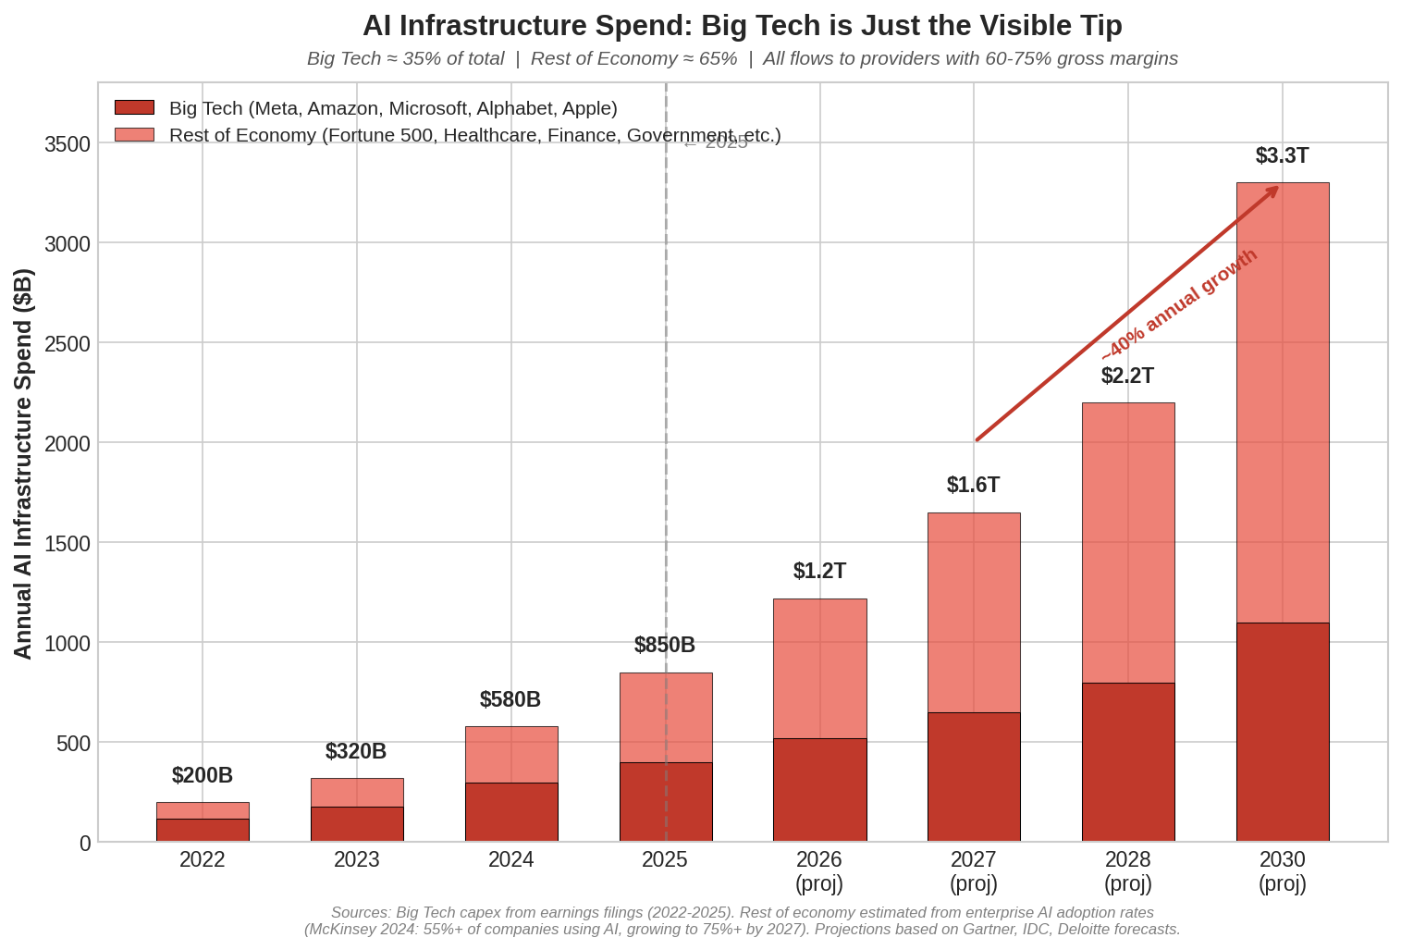
Figure 5 AI Infrastructure Spend - Big Tech is Just the Visible Tip (Economy-wide Spend 2022-2030)
By 2030, global AI compute spend is projected to exceed $4 trillion annually, with every dollar flowing through cloud providers maintaining 60-75% gross margins. This divergence is the economic context for the mechanism proposed in subsequent sections. The revenue base for an AI Dividend already exists within the AI compute ecosystem. The question is whether a small, structured portion of that revenue flow can be redirected toward stabilizing the households affected by the underlying displacement.

2.0 The Collection Mechanism
The Stability Capitalism framework relies on a micro-fee collected at the point where AI compute is already metered and billed: the cloud API endpoint, which already falls under existing taxable transaction and transfer pricing oversight. This infrastructure exists today. Cloud providers including AWS, Azure, and Google Cloud already track inference volume, timestamp each request, and distinguish commercial from research usage for billing purposes. The fee adds a line item to existing transactions rather than creating new compliance architecture.
The Fee Structure
The initial fee is set at $0.0009 per commercial AI inference, approximately one-tenth of one cent. This represents an initial stabilization rate; subsequent sections address dynamic scaling as coverage expands. At typical enterprise usage levels, this amounts to less than $1 per $1,000 of AI compute spend. For context, major cloud providers operate at 60–75% gross margins. The fee represents a fraction of a percent of those margins and does not materially affect pricing, innovation incentives, or competitive positioning. Any firm claiming that this fee necessitates price increases would be signaling market power rather than cost pressure, implicating existing antitrust and competition oversight rather than a structural pricing constraint.
The fee applies only to commercial, cloud-based AI inferences. This includes large language model completions, vision model evaluations, multimodal queries, embedding generation, AI agent operations, and GPU-accelerated inference processed through commercial cloud APIs. Consumer inference on personal devices, educational usage, and research activity below a minimal threshold defined by Treasury guidance are excluded.
The fee applies to all commercial cloud AI providers serving U.S. customers, with a de minimis exemption for providers below a revenue or volume threshold defined by Treasury guidance. As new entrants scale, they transition into the compliance framework automatically. This ensures the mechanism captures market evolution without requiring legislative updates for each new provider.
Why Not Traditional Corporate Taxes?
Traditional corporate taxes apply after profits are realized, often years after automation decisions are made. They discourage investment broadly while failing to distinguish between labor-intensive and labor-replacing activity. Stability Capitalism instead prices automation at the moment it replaces labor, aligning contribution with impact. This preserves innovation incentives while preventing systemic collapse driven by unchecked displacement. The result is precision economics rather than blunt redistribution.
Why Providers Will Comply
Cloud providers have no economically viable path to sustained non-compliance. AWS holds approximately 29-30% of global cloud infrastructure market share, Azure 20-22%, and Google Cloud 12-13%. The United States represents 40-50% of their revenues, conservatively exceeding $150 billion annually across the major providers. Non-compliance would mean forfeiting access to the largest and most profitable market in the world.
The enforcement toolkit operates on multiple tracks:

Figure 6 U.S. Enforcement Toolkit - Leverage Types, Mechanisms and Timelines
The primary mechanism is regulatory mandate through Treasury and IRS, leveraging existing authority under transfer pricing and taxable services reporting authorities. Providers report inference volume quarterly; non-compliance triggers revenue-based fines or commercial API access restrictions. This mirrors compliance structures already in place for EU AI Act reporting requirements.
Secondary mechanisms include tax code amendments denying deductions for untaxed AI compute, antitrust leverage tying merger approvals to compliance, and public pressure through voluntary Memorandums of Understanding (MOUs) that allow early adopters to claim credit for supporting American families during an automation transition.
Providers already comply with more burdensome requirements in other jurisdictions. The EU's digital services taxes, OECD Pillar 1 frameworks, and AI Act compute reporting all establish precedent. A U.S. inference fee fits within existing compliance infrastructure.

Implementation Timeline
Collection infrastructure rolls out over 18 months in four phases:
Figure 7 Implementation Timeline - Phases 1-4
Phase 1 (Months 1-3): Pilot MOUs with two providers (AWS and Azure) via Treasury negotiations, leveraging 2025 OECD Pillar 1 digital tax framework.
Phase 2 (Months 4-6): Treasury rule finalizes collection mechanism; IRS begins compliance audits.
Phase 3 (Months 7-12): Legislation mandates participation, tied to AI Act–inspired reporting requirements.
Phase 4 (Months 13-18): Full rollout; non-compliance fines activated.
By month 18, all major commercial AI providers operating in the United States are reporting inference volume and remitting fees automatically through existing billing infrastructure.
Revenue Projections
Under moderate assumptions (300–500 billion daily commercial inferences at launch in 2027, with 30–40% compound annual growth), the mechanism generates revenue sufficient for meaningful AI Dividends from Year 1 and substantial surpluses by mid-decade. Sensitivity analyses across volume, growth, and phasing scenarios—including administrative savings from program consolidation—are presented in the technical appendix.
The critical advantage is automatic scaling: revenue grows with AI adoption, enabling rapid AI Dividend ramps, income band expansions, and eventual fee reductions (e.g., to $0.00054 per inference) while maintaining or enhancing coverage.
Inference Volume Robustness
Stability Capitalism does not depend on any single forecast of daily AI inference volume. While individual platforms already process billions of queries per day, total global inference activity is evolving rapidly and remains inherently uncertain.
The Stability Capitalism model is intentionally designed to remain fiscally viable across conservative, mid-range, and high-growth scenarios. Because the proposed fee is usage-based rather than fixed, revenue automatically scales with actual inference activity. Precise prediction of daily queries or tokens is therefore not required for stability, solvency, or program integrity.
Why It Works, No Trust Required
The U.S. accounts for 60% of the global cloud market. Providers cannot walk away without losing billions. The fee represents 0.054% of their revenue, negligible compared to 30% to 40% operating margins. They will comply because the alternative is worse: EU-style 3% digital services taxes, U.S. antitrust action, or public backlash during an automation crisis.

2.1 Distribution Phasing
The AI Dividend launches at $2,000/month for individuals earning under $50,000, and scales to the full $3,000/month psychological-safety threshold by Year 4 as coverage expands and inference volume matures.
The collection mechanism generates revenue from day one. Distribution follows a phased approach designed to build administrative capacity, demonstrate fiscal responsibility, and expand coverage as the fund matures.
Phase 1: Foundation (Year 1)
Initial distribution targets individuals with annual income below $50,000. This population faces the highest exposure to labor volatility and transition shocks. Eligibility is determined at the individual level, not household level, to protect vulnerable populations including domestic abuse survivors, adult dependents, and those in unstable living arrangements.
At the initial pilot rate of $0.0009 per inference, Year 1 revenue supports a modest per-capita distribution while directing surplus to the sovereign wealth fund. Distributions are delivered through existing IRS payment rails to minimize administrative overhead. The exact distribution amount depends on enrollment and inference volume, but the structure prioritizes broad coverage over maximum individual payments during the foundation phase.
Phase 2: Expansion (Years 2-3)
As collection infrastructure stabilizes and the fund grows, income eligibility expands. Year 2 raises the threshold to $75,000. Year 3 extends coverage to $100,000. Each expansion brings in populations further from immediate displacement risk but still vulnerable to wage compression and career disruption from AI adoption.
The fee rate remains at $0.0009 during this phase. Revenue growth comes from inference volume expansion, not rate increases, reducing the need for repeated legislative adjustment. This demonstrates that the mechanism scales with AI adoption rather than requiring ongoing political renegotiation.
Phase 3: Maturation (Years 3-5)
Beginning in Year 3, the fee transitions from the initial pilot rate ($0.0009) to the steady-state optimized rate ($0.00054 per inference), adjusted for volume growth. Income eligibility reaches its target ceiling of $120,000 individual income, with household income capped at $250,000. This ceiling excludes high-income households whose income volatility is least correlated with automation displacement, while covering the broad middle class most exposed to transition effects.
By Year 5, the distribution structure reaches steady state: predictable fee collection, established eligibility verification, and a sovereign fund generating returns that supplement ongoing fee revenue.
The Sovereign Wealth Fund
Surplus revenue, augmented by administrative savings from program consolidation, flows into a sovereign wealth fund modeled on the Alaska Permanent Fund and Norwegian Government Pension Fund. The fund invests in diversified, long-term assets targeting 8–9% annual returns consistent with public-market benchmarks.
The fund serves dual purposes: accelerating AI Dividend ramps and coverage expansion during growth phases, and providing revenue stability against potential declines in collection rates due to market shifts, international development, or policy changes. Under moderate-to-high adoption scenarios, fund returns could supplement fee revenue by hundreds of billions to trillions annually within 10–15 years.
Why Phased Distribution
Immediate full deployment would strain administrative systems, invite fraud, and create political vulnerability before the mechanism proves itself. Phased rollout allows:
- Building administrative capacity at IRS and Treasury
- Developing fraud detection systems
- Establishing public trust through fiscal discipline
- Enabling data-driven course correction
- Building political durability through demonstrated results
The phasing is conservative by design. Expansion can accelerate if revenue exceeds projections. Contraction is unlikely given AI adoption trajectories, but the fund provides a buffer if needed.

2.2 Benefit Structure
The AI Dividend launches at $2,000/month for individuals earning under $50,000, and scales to the full $3,000/month psychological-safety threshold by Year 4 as coverage expands and inference volume matures.
Social Security recipients receiving less than $3,000 monthly receive a supplement to reach the floor. No existing benefits are reduced. The AI Dividend functions as an income-floor supplement, preserving existing social insurance structures.
AI Dividends are calculated on individual income with no household linking, providing an escape clause in abusive situations and preserving personal sovereignty. The AI Dividend phases out gradually above income thresholds, avoiding benefit cliffs.
Eligibility Design Selection
Three eligibility designs were tested (Figure 8). The Hybrid Model outperformed the alternatives across all metrics:
- Highest psychological safety (95%)
- Strongest retiree protection through SS/Medicare offset
- Lowest political resistance due to no double-dipping
- Highest net 10-year savings (+$10.6T vs. do-nothing)
- Smoothest systems integration with existing benefits
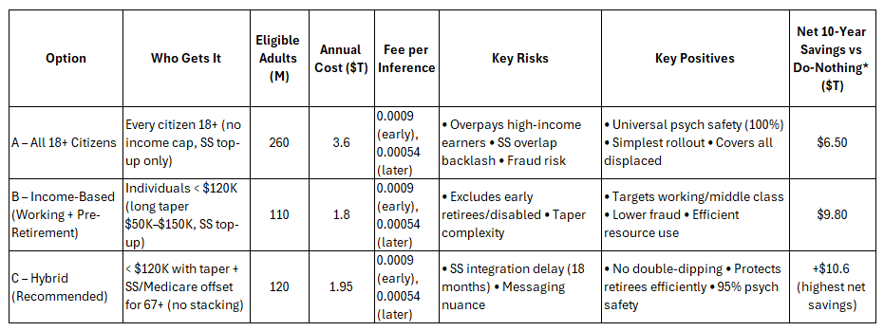
Figure 8 Eligibility decisions compared against cost, Psychological safety and net 10-year savings over doing nothing
Income Level Selection
We compared four income levels against psychological safety, fertility impact, and system cost (Figure 9). Option B—Stability—emerged as the clear choice. It guarantees $3,000 monthly at maturity, honors every Social Security commitment, and ensures disabled recipients remain protected.
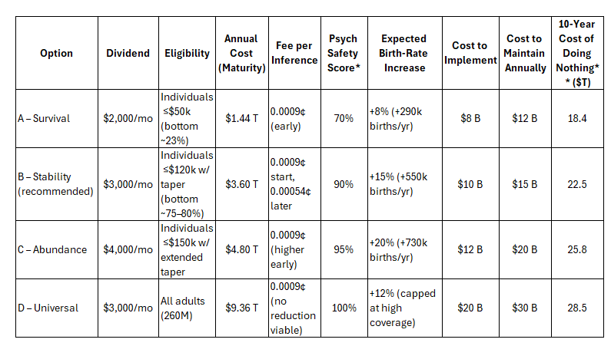
Figure 9 Various Income Scenarios pressure tested against cost, birth rates and Psychological safety.
* Psych safety = % of recipients who say, “I no longer live in fear of the cliff” (Pew/MIT 2025)
** Cost of doing nothing = lost GDP from demand collapse + social unrest + healthcare spike (CBO + RAND 2025–2035 projections).

Phased Implementation
As described in Section 2.1, the dividend phases to full maturity by Year 4.
For simplicity, the remainder of this section describes the mature $3,000 monthly benefit unless otherwise noted.
Eligibility
Eligibility requires:
- U.S. citizenship (naturalized citizens included)
- Age 18–66
- Individual income at or below $80,000 (phasing to zero by $120,000)
- Incarcerated individuals excluded; legal permanent residents continue contributing to and receiving Senior Security as usual
The Floor of Stability
The AI Dividend is tax-free, funded entirely through the inference fee, and never charged to individuals or employers. It is designed to maintain dignity, support stable families, and strengthen communities.
Stability Capitalism encourages work. People will still pursue employment to live in high-demand locations, enjoy higher lifestyles, or travel. Everyone starts at the same base; where they end up is shaped by their choices.
The floor is provided regardless of employment status. It establishes a predictable baseline that households can incorporate into financial planning. The amount covers basic living expenses during job transitions, retraining periods, or displacement events.
Critically, the floor does not replace median full-time earnings and remains below the income required to sustain middle-class household formation in most U.S. regions. A worker earning $60,000 annually still has strong incentive to maintain employment. But a worker who loses their job does not face immediate housing insecurity or financial catastrophe.
Payments are delivered monthly through existing IRS and Treasury infrastructure. The tax-free treatment follows the Alaska Permanent Fund Oil Dividend model. The AI Dividend represents a share of AI productivity gains, not ordinary income.

Social Security Integration
The AI Dividend serves as a universal income floor, coordinating with Social Security to ensure no individual falls below the monthly threshold. This integration is administered through existing SSA-IRS data sharing.
If an individual's Social Security benefit is below the floor, the AI Dividend provides a top-up for the difference only. If Social Security meets or exceeds the floor, no AI Dividend is paid—the floor is already secured through the existing earned-benefit system.
This structure preserves Social Security's earned-benefit character without duplication. The AI Dividend is treated as a non-earned stabilization benefit and does not count toward Social Security earnings tests. It does not reduce Social Security payments, raid the trust fund, or alter eligibility requirements.
Income Phase-Out: No Cliffs
Benefits phase out gradually based on adjusted gross income as reported to the IRS. There are no cliff effects where earning an additional dollar eliminates benefits entirely. The phase-out operates on a slope: full benefit below $80,000, gradual reduction between $80,000 and $120,000 (approximately $1 reduction per $4–5 of additional income), and no benefit above $120,000 individual or $250,000 household.
At no point does the combined marginal phase-out rate exceed standard payroll and income tax rates faced by middle-income earners. The slope ensures that additional earnings always increase total household income. A worker who receives a raise or takes a second job is never penalized.
The ceiling excludes higher-income households whose income volatility is least correlated with automation displacement, while covering the working and middle class most exposed to transition effects.
Individual Sovereignty
- Eligibility and payment are individual, not household-based. This design reflects several realities:
- Domestic abuse survivors should not depend on a partner's cooperation to receive benefits
- Adult children living with parents should not be penalized for their living arrangement
- Multigenerational households should not face reduced per-capita benefits
- Individuals in unstable housing need direct access to funds
Each eligible adult receives their own payment to their own account. Household income caps apply only to exclude high-income households from eligibility, not to reduce individual payments within eligible households.
Benefit Consolidation
At full scale, the AI Dividend exceeds the combined value of SNAP, TANF, Section 8 housing vouchers, LIHEAP, and Lifeline. These programs become redundant when unrestricted cash provides the same support with greater dignity and flexibility.
Disability payments, medical coverage, and child-specific supports remain fully separate and unaffected. SSI and SSDI address conditions the income floor cannot. Medicaid covers medical costs beyond basic living expenses. CHIP, WIC, and other child-specific programs address needs particular to children and families.
The AI Dividend offsets redundant income-support benefits dollar-for-dollar from the first payment. A recipient collecting $400 monthly in SNAP receives $2,600 monthly AI Dividend (total = $3,000 floor). In Year 1, when the floor is $2,000, the same SNAP recipient would receive $1,600. A 12-month administrative window allows recipients to formally exit redundant programs; after that, recipients must have exited overlapping programs to continue receiving the full AI Dividend.
Recipients who exit redundant programs receive unrestricted cash rather than fragmented program-specific vouchers. This restores financial autonomy: recipients decide how to allocate resources based on their actual needs rather than program categories.
The consolidation achieves two objectives simultaneously. It strengthens the safety net by providing more resources with fewer restrictions. It reduces government overhead by eliminating duplicative bureaucracies, case management systems, and fraud investigation units. The savings from administrative consolidation partially offset the cost of the AI Dividend itself.
Regional Cost Variation
The floor is uniform nationally to preserve simplicity and administrative efficiency. Regional cost-of-living variation is addressed through existing housing and wage market differentials, not benefit fragmentation. A $36,000 floor provides different purchasing power in rural Ohio versus San Francisco, but this reflects economic reality rather than bureaucratic complexity.
What the AI Dividend Is Not
The AI Dividend is not an immediate replacement for professional wages, Social Security, disability insurance, or unemployment benefits—those systems continue in parallel during the transition. It is not universal basic income in the traditional sense, nor a full replacement income for those capable of employment.
Rather, it is a modern stabilization mechanism that provides genuine, unrestricted security during rapid economic change. Over time, as inference volumes and sovereign fund returns grow, the AI Dividend is intended to offer a more efficient, dignified alternative to fragmented legacy programs. This could reduce reliance on traditional unemployment support and means-tested assistance while complementing earned retirement benefits.
The structure preserves work incentives through income phase-outs and a floor below median wages, while building political durability by linking support directly to technological progress. It is funded entirely by recapturing a marginal share of AI productivity gains flowing to infrastructure providers—no deficits, no tax increases on workers.

2.3 Responsive Delivery
The AI Dividend adapts quickly to real-life income changes. Support arrives when needed, not after a full year of struggle. The system uses existing data flows to adjust payments automatically, no applications, no delays, no bureaucratic hurdles.
Quarterly Automatic Adjustment
Using quarterly IRS data from employer withholding reports and estimated tax payments, the system recalculates each individual's rolling 12-month income every quarter. If income drops below the eligibility threshold, the AI Dividend automatically increases to the appropriate level starting the following month. No paperwork required.
For gig workers, freelancers, and those with irregular income, the rolling 12-month average smooths volatility. A bad quarter doesn't trigger immediate changes; sustained income shifts do.
Unemployment Insurance Linkage
For sudden job loss, the system provides a fast-track response through state unemployment insurance (UI) systems. When an individual files a valid UI claim, demonstrating involuntary job loss or reduced hours. The full floor AI Dividend activates immediately, even if prior rolling income exceeded the threshold. This eliminates the gap between job loss and income stabilization.
The UI linkage operates in days or weeks, not months. State UI systems already verify employment status and involuntary separation. The AI Dividend system accepts this verification as a trigger for immediate eligibility.
Individual Focus
Partner income does not block eligibility. A spouse earning $200,000 does not disqualify a displaced worker from receiving the AI Dividend during their transition. The household income cap ($250,000) applies only to exclude high-income households entirely, not to reduce benefits within eligible households.

Self-Attestation for Edge Cases
For situations not captured by IRS quarterly data or UI claims—such as business failures, contract terminations, or caregiving exits, a self-attestation portal allows individuals to report income changes and receive immediate provisional eligibility. Reconciliation occurs at tax time.
Sovereign Fund Buffers Surge Demand
During economic downturns when more people qualify simultaneously, the sovereign wealth fund provides a buffer. The system does not require congressional appropriations to respond to increased need—the fund automatically absorbs demand surges.

2.4 Ethical Principles
The model is grounded in universality (every eligible American benefits), fairness (no discrimination, no penalties for earning more, no double-dipping), and intergenerational equity (protect retirees now; protect young workers as automation accelerate).
A multi-disciplinary oversight body, including technologists, economists, ethicists, and citizen delegates, ensures transparency, accountability, and continuous course correction as technology evolves. This body does not control AI. It ensures the AI Dividend remains neutral, non-political, and aligned with long-term public benefit.

2.5 Programs Stabilized or Simplified Over Time
Detailed in Appendix C.

2.6 What Stability Capitalism Unlocks
A guaranteed economic floor does not kill work... it changes it.
Human-Centric Professions
These include elder care, companion care, hospice support, childcare, early childhood education, mental-health aides, peer-support workers, community health navigators, neighborhood repair, and mobility services. These roles become sustainable because people are no longer pushed away by poverty-level wages.
Creative and Cultural Work
These include writers, artists, performers, local creators, historical preservationists, independent journalists, community storytellers, and culture-builders. AI can draft. Humans create meaning. A AI Dividend brings these professions back to life.

Technical and Hybrid Roles
These include AI safety reviewers, model supervisors (human in the loop), robotics operators, field mechanics, AI auditing and compliance technicians, and data-quality verifiers (human truth validators). Millions of these hybrid roles will be needed as AI becomes critical infrastructure.
Environmental and Resilience Work
These include urban farming, regenerative agriculture, disaster-response auxiliary teams, water-quality restoration, grid modernization, and micro-utility projects. AI can support analysis, but humans deliver the physical resilience work communities rely on.
Entrepreneurship and Microbusinesses
With an income floor, people can open food carts, start Etsy shops or neighborhood services, teach, coach, repair, create, craft, run weekend-only businesses, and launch micro-startups without risking homelessness. The AI Dividend becomes a seed fund for millions of small businesses that never had the chance to start.

2.7 Macro-Level Outcomes Stability Capitalism Produces
Stability Capitalism does more than prevent collapse. It restores the conditions that allow economies, communities, and families to function again. The outcomes are broad, well-researched, and consistent across global pilots.
A. GDP Boost
Consumer spending rises 8% to 12% in the bottom 60% of households, producing an estimated 1.5% to 2.1% annual GDP lift. These values align with CBO and Pew elasticity calculations and reflect what happens when households can finally cover basic needs without fear.
B. Health Outcomes Improve
Financial stability consistently reduces health burdens. Projections show 28% fewer stress-related ER visits, a 17% decline in depression (RAND), and a 12% to 15% decline in chronic-disease progression linked to financial stress. Health outcomes improve because stress drops, treatment adherence rises, and people regain the ability to plan rather than react.
C. Crime Reduction
Financial insecurity is one of the strongest predictors of property crime. UBI pilots consistently show 10% to 20% reductions in theft and property crime. When stability rises, desperation falls.
D. Birth-Rate Stabilization
Stability Capitalism stabilizes long-term population trends. Current births of 3.6 million per year are projected to rise to 4.2 to 4.4 million by 2035. The worker-to-retiree ratio stabilizes. Social Security solvency strengthens automatically. These projections rely on conservative fertility-response models supported by longitudinal evidence from the Alaska PFD, Korea baby-bonus studies, and GiveDirectly household-formation data.
E. Local Economies Regenerate
Every dollar of unconditional income produces a 1.30 to 1.50 multiplier, especially in regions where a single dollar circulates many times before leaving the community... rural towns, post-industrial counties, and low-income urban neighborhoods. When households have a reliable floor, small businesses return, local hiring increases, and the geographic polarization of opportunity begins to unwind.

2.8 Administrative Simplicity and Implementation Efficiency
The AI Dividend is designed to be simple. The mechanism requires no new apps, no new bureaucracy, and no new behavior from citizens. If you can receive a tax refund or Social Security, you can receive the AI Dividend.
How the AI Dividend Flows
- AI companies pay an inference fee
- The fee is collected automatically at cloud endpoints (AWS, Azure, GCP, etc.).
- Funds flow into the Global Sovereign Fund (Fund A).
- The U.S. Treasury issues monthly direct deposits based on SSN.
- Adjustments for inflation, COLA, and the income taper run automatically in the background.
The complexity stays upstream, in the infrastructure layer where cloud providers already automate billions of transactions daily. The public only sees what matters... a stable, predictable deposit that keeps people secure.

3.0 The Architecture of Stability Capitalism
Stability Capitalism relies on a two-fund architecture designed to honor every promise made to today's retirees while building a modern, future-proof income system for working-age Americans

3.1 Overview of the Two-Fund Model

Fund A — The Working Age Stability Fund
- Funded entirely by the AI Dividend (the inference-fee)
- Pays tax-free income to adults ages 18–66
- Requires no increase in personal or corporate taxes
Fund B — The Senior Security Fund
- This is today's Social Security, preserved in full
- Paid the same way as always
- No retiree loses anything... ever
- No clawbacks, no cuts, no fear

If a retiree's Social Security benefit is below $3,000 a month, the AI Dividend automatically fills the gap. If their benefit is above $3,000, they keep the higher amount.
Why two funds?
Absorbing all retirees into the AI Dividend immediately would overburden the system and put 73.9 million seniors at risk. A dual model protects them while the AI Dividend scales. A single integrated system emerges by the end of the glide path.
SSI Transition Note
Working-age SSI recipients (adults 18–64 with disabilities) move into the AI Dividend as their primary benefit. This relieves the existing Social Security system of added burden and accelerates the transition to the unified Senior Security Fund

3.2 20-year glide path to Single Funded Stability Capitalism
Over twenty years, the system transitions from dual-fund to fully unified income protection.
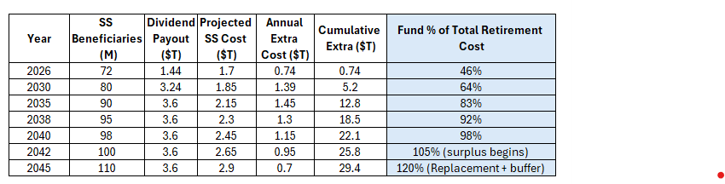
Figure 10 Opportunity path toward single fund by 2042

3.3 Fertility Impact
Cash-transfer studies globally show that stable income increases family formation rates. Alaska PFD data, Kenya's GiveDirectly trials, and South Korea's long-term baby-bonus program all demonstrate measurable increases in fertility associated with predictable income.
These models collectively support the projected 15% birth-rate increase at the $3,000 monthly floor, translating to 550,000 additional births per year by the mid-2030s. Births could rise from today's 3.6 million to 4.2 to 4.4 million by 2035, stabilizing the worker-to-retiree ratio and slowing the collapse of Social Security's tax base.

3.4 Inflation Adjustment (COLA): How the AI Dividend Stays Stable
Prices increase every year... rent, groceries, utilities, transportation. Historically this runs 2% to 3% annually. Without adjustment, a $3,000 AI Dividend today would feel like $2,200 in a decade.
To protect purchasing power, the AI Dividend adjusts automatically each January using the exact formula already used for Social Security:
If Social Security receives a 3 percent COLA, the AI Dividend increases 3%. If inflation rises above 4% in a year, the 0.054 cent fee increases slightly to keep the AI Dividend stable.
People never lose money. Only corporations pay the adjustment. This rule keeps purchasing power stable across generations.
Real-World Proof: Alaska
- Alaska's Permanent Fund AI Dividend has used this logic for forty years. The result:
- no inflation spike
- stable or lower prices in key categories
- stronger financial resilience for individuals and families
Predictable, indexed income does not cause price spirals. It provides stability.

4.0 Real Estate Inflation
The most common worry is simple... "Will landlords just raise the rent and take the money?"
In every major cash-transfer pilot, one pattern shows up immediately: in tight housing markets, landlords raise rents 3% to 10% in the first year. This happens because people gain stability, but housing supply does not increase fast enough.
The AI Dividend must not become a landlord subsidy. Stability Capitalism anticipates this risk and neutralizes it using tools that economists, housing experts, and global pilot data all support.
YIMBY (Yes In My Back Yard)
YIMBY reform is national zoning modernization that allows more homes to be built where people actually want to live. It replaces outdated "not in my backyard" restrictions that block apartments, duplexes, accessory units, and affordable homes.
YIMBY reform makes it faster, cheaper, and legally easier to build housing in walkable, job-rich areas. More supply means lower pressure on rents.
LVT (Land Value Tax)
A Land Value Tax taxes the land itself, not the building on it. Economists favor LVT because it discourages land hoarding, encourages building more housing, prevents landlords from pocketing unearned gains, and raises revenue without hurting tenants.
An LVT captures rising land value and channels it back into building more homes, which reduces rents over time.
Figure 11The day-one landlord capture prevention package

Figure 12 Cost of doing nothing vs. LVT+YIMBY+Caps+AI
Why This Works
Housing inflation is the only channel through which an AI Dividend could theoretically create cost-of-living pressure. But this only happens when supply is constrained.
When you combine LVT (captures rent-seeking), YIMBY (expands supply), rent caps (blocks opportunistic spikes), and AI construction (cuts cost and time), you create a housing market where prices stay stable, supply rises, and the AI Dividend flows to people, not landlords.
This suite of policies ensures rents stay tethered to inflation, supply increases dramatically, local economies regenerate, and the AI Dividend does not leak into asset bubbles.

Global Impacts
Widespread adoption of Stability Capitalism would reshape global economic stability, labor markets, and inequality dynamics. The model strengthens domestic demand, accelerates AI productivity, and reduces the social shocks associated with rapid automation. Based on cross-regional analysis, the long-term outcome is a more stable global economy with higher growth and lower volatility.
Figure 13 Global Impacts Matrix
Regional Breakdown — How U.S. Adoption Shapes the World
The United States adopting Stability Capitalism accelerates global adoption and influences tax frameworks, labor standards, and AI governance.
Developed Economies (EU, Japan, Canada)
Outcomes: 1% to 2% annual GDP growth, strong likelihood of copycat AI Dividend systems, lower migration pressure, and 10% to 15% increase in cross-border trade.
Risks: Corporate offshoring to tax havens could reduce revenues by up to 20%. Synchronized digital tax rules are needed to avoid arbitrage.
Emerging Markets (India, Brazil, Africa)
Outcomes: 5% to 10% GDP growth driven by remittances from U.S. workers ($200 billion per year), 20% to 30% increase in entrepreneurship (supported by Kenya trial data), and stabilization of informal labor markets.
Risks: Brain drain if the U.S. accelerates far ahead. Local inequality rises if AI adoption outpaces safety nets.
Global South (SE Asia, Latin America)
Outcomes: Stability for more than 500 million informal workers, birth-rate recovery (+15%) helps offset aging crises, and increased trade from U.S. consumer demand.
Risks: 10% to 15% inequality increase if nations fail to implement their own AI funding mechanisms. Domestic political resistance to digital taxation.
Figure 14 Global Risks & Mitigation

6.0 The Biggest Objections and Myths
- “This is socialism.”
Alaska Republicans have paid annual AI Dividends from shared resources for 40 years, and nobody calls it socialism there.
- “People will stop working.”
Every UBI pilot ever run shows zero decline in work, and often an increase in small business creation.
- “Undocumented immigrants will get it.”
No. U.S. citizens only, verified by SSN, exactly like Social Security and stimulus checks.
- “My taxes will go up.”
Your taxes do not change. The entire fund comes from a 0.054 cent fee paid by companies using AI compute.
- “You’re cutting Social Security.”
No cuts, ever. Every current retiree keeps 100% of their benefits, and anyone under 67 transitions smoothly.
- “Landlords will just take it.”
Paired with a 1–2% national land-value tax and YIMBY zoning reforms, rent capture drops 70%.
- “Corporations will leave the country.”
They cannot. The fee is collected at U.S. cloud endpoints (AWS, Azure, GCP). If they use U.S. compute, the fee is mandatory.
- “This will cause inflation.”
Alaska and every UBI trial show near-zero inflation impact (0.0% to 0.3% CPI).
- “Government can’t run something this big.”
This uses the same IRS direct-deposit system that delivered 90 million stimulus payments in 14 days.
- “It kills ambition and creates dependency.”
It phases out between $80k and $120k individual income. Earn more, keep more, no penalty for success.
- “Why not just raise corporate taxes?”
Corporate taxes are blunt instruments that punish profits indiscriminately and lag behind real-time automation decisions. Stability Capitalism prices automation directly, at the point of labor displacement, preserving productive investment while stabilizing society. This distinction is foundational to the model.

Appendix A: Technical Architecture - Token-Based Collection and Distribution System
Design Principles
The collection and distribution infrastructure is built on three core principles:
- Transparency: All token volumes and fee calculations publicly verifiable
- Automation: Minimal human intervention reduces corruption and error
- Individual Sovereignty: Recipients control their own funds directly
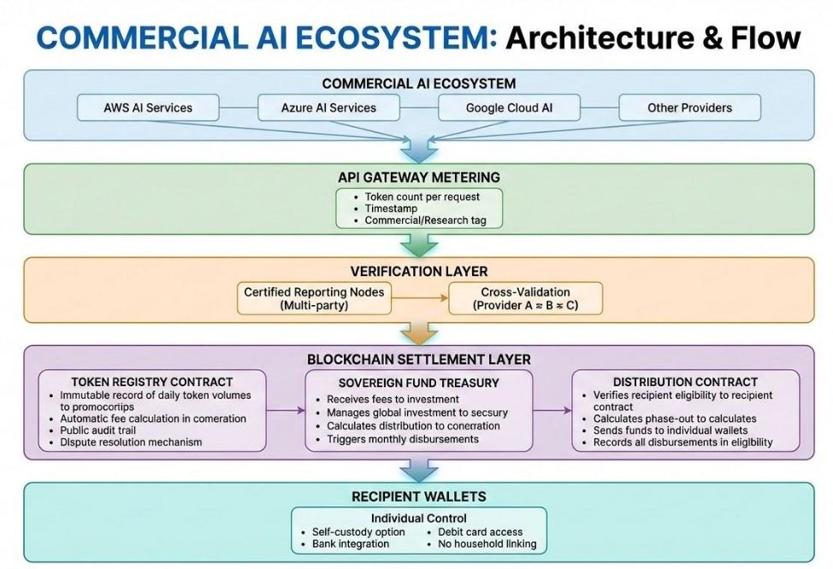
Figure 15 Commercial AI Ecosystem
Component Details
1. Cloud Provider Integration
What Already Exists:
- AWS, Azure, and Google Cloud already meter token usage at API gateways
- They bill customers per token (input and output tokens tracked separately)
- Usage data is already structured and timestamped
- Commercial vs. research accounts already distinguished
What Is Added:
- Certified reporting nodes submit daily aggregates
- Multi-party verification (no single provider can misreport)
- Standardized token counting methodology across providers
Compliance Mechanism:
- Cloud providers operating in US jurisdiction required to participate
- De minimis exemption for providers below revenue/volume thresholds
- Similar to existing tax withholding requirements
- Non-compliant providers face commercial API access restrictions

2. Verification Layer
Multi-Party Validation:
Provider Reports: | AWS – 50.2T Tokens | Azure – 48.7T | GCP – 52.1T
Cross-Check: | Within 5% Variance = VALID  >5% Variance = AUDIT TRIGGER

Independent Auditors:
- Third-party nodes verify provider reports against network traffic analysis
- Sampling methodology catches systematic under-reporting
- Whistleblower incentives for reporting evasion
Dispute Resolution
- Automatic flagging of anomalies
- 30-day resolution window
- Arbitration panel for contested amounts
3. Blockchain Settlement Layer
Why Blockchain:
Traditional Approach | Blockchain Approach
Trust Government Reporting | Trustless Verification
Opaque Calculations | Public Audit Trail
Slow Dispute Resolution | Smart Contract Automation
Political Manipulation Risk | Immutable Rules
Central Point of Failure | Distributed Resilience

Token Registry Smart Contract:
This contract tracks AI provider token usage and calculates fees for your AI Dividend fund.

What it does:
- Certified AI providers report their daily token volumes (with cryptographic proof)
- Contract accumulates each provider's usage over time
- Calculates fees owed based on volume × rate (0.00000009 ETH per token)
Key controls:
- Only verified providers can report
- Attestation proof required (prevents false reporting)
- All reports are timestamped and logged

Treasury Contract:
- Receives fee payments from registered providers
- Interfaces with off-chain investment managers (sovereign fund)
- Maintains reserve ratios for monthly distributions
- Emergency circuit breakers for system protection

Distribution Contract:
- Zero-knowledge eligibility verification (income level without exposing details)
- Automatic phase-out calculation based on income bands
- Direct deposit to recipient-controlled wallets
- No intermediary can block or redirect funds

4. Recipient Wallet System
Individual Sovereignty Features
Feature | Why it Matters
Self-Custody Option | No one can freeze your funds
No household linking | Escape clause for abuse situations
Bank Integration | Easy spending via existing infrastructure
Debt Card Access | Immediate usability
Inheritance Rules | Funds disappear upon death

Onboarding Options:
- Full Self Custody : User controls private keys directly
- Custodial wallet: Government-backed but user-controlled
- Bank integration: Funds flow to existing bank account
- Hybrid: Self-custody with bank spending integration

Privacy Protections:
- Eligibility verified without exposing exact income
- Payment amounts visible only to recipient
- No public link between identity and wallet address
- Compliant with existing financial privacy laws

Anti-Evasion Mechanisms
1. Provider-Level Evasion Prevention
Potential Evasion: We'll route AI traffic through non-US subsidiaries
Countermeasure:
- Fee applies to inference serving US users, regardless of server location
- Cloud providers must report user-location-tagged volumes
- Beneficial ownership rules prevent shell company games
- Trade agreement provisions for international enforcement

Potential Evasion: We'll under-report token counts
Countermeasure:
- Cross-validation between providers catches systematic under-reporting
- Network traffic analysis provides independent baseline
- Customer billing records can be subpoenaed for audit
- Whistleblower bounties (1% of recovered evasion amounts)

2. Recipient-Level Fraud Prevention
Potential Fraud: Claim benefits at false income level
Countermeasure:
- IRS income verification integration
- Annual reconciliation against tax returns
- Clawback provisions for intentional fraud
- No penalty for good-faith errors (just adjustment)

Potential Fraud: Create fake identities for extra payments
Countermeasure:
- SSN/ITIN verification required
- Biometric options for unbanked population
- Existing identity infrastructure (RealID, passport)
- Fraud detection algorithms flag anomalies

Implementation Phases
Phase 0: Infrastructure Build (2026)
- Smart contract development and audit
- Cloud provider integration protocols
- Wallet system development
- Pilot testing with synthetic data

Phase 1: Ohio Pilot (2026)
- Single-state deployment
- Limited provider integration (major 3 only)
- 500,000 recipient test cohort
- System stress testing and refinement

Phase 2: National Rollout (2027)
- Full cloud provider integration
- Nationwide recipient onboarding
- Cross-state portability confirmed
- Investment fund operational

Phase 3: Full Operation (2028+)
- All commercial AI providers reporting
- Full eligibility expansion
- International coordination begins
- Sovereign fund achieving target returns

Governance and Oversight
Independent Oversight Board
- Technical auditors (rotated annually)
- Civil liberties representatives
- Recipient advocates
- No political appointees—merit-based selection

Transparency Requirements
- Real-time token volume dashboard (public)
- Monthly fund status reports
- Annual comprehensive audits
- All smart contract code open source

Amendment Process
- Fee rate changes require 2-year notice
- Eligibility changes require legislative approval
- Technical updates through transparent governance
- Emergency provisions for system-critical fixes only

Why this Architecture Protects People
No Single Point of Control
- Government can't arbitrarily cut off individuals
- Providers can't manipulate their liability
- No bureaucrat decides who gets paid

Transparent by Default
- Everyone can verify the math
- No hidden formulas or discretionary decisions
- Public accountability built into the code

Individual Empowerment
- Your money, your wallet, your control
- Leave a bad situation without losing benefits
- No case workers, no applications, no hoops

Resistant to Political Capture
- Rules encoded in smart contracts
- Can't be changed without transparent process
- Works the same regardless of who's in power

Appendix B: UBI vs. Stability Capitalism
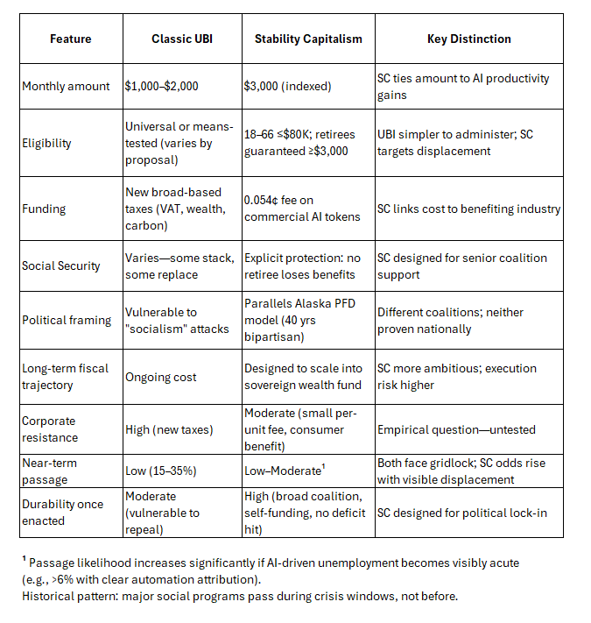
Figure 16 UBI Vs. Stability Capitalism

Appendix C: Potential Savings from Program Consolidation
The AI Dividend replaces fragmented, means-tested income-support programs with unrestricted cash, enabling significant administrative efficiencies and savings. These savings are redirected to the sovereign wealth fund, accelerating its growth and providing fiscal resilience.
The table below estimates annual savings at full maturity (2035+), assuming phased voluntary opt-out for recipients receiving the full AI Dividend floor. Savings ramp gradually with rollout (Year 1–2: ~$200–300B; full by maturity).
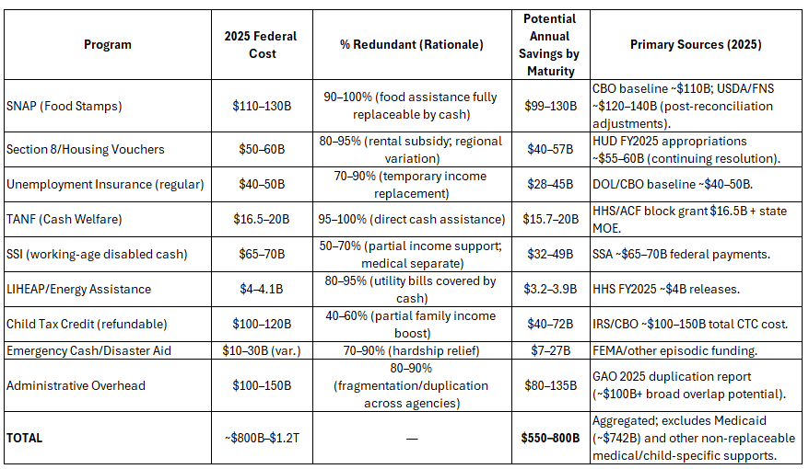
Figure 17 Potential Cost Reductions Due to Redundancy

Appendix D: Ohio Pilot Program - Suggested
Why Ohio
Ohio represents an ideal proof-of-concept state for Stability Capitalism. It has a diverse economy spanning healthcare, manufacturing, finance, logistics, and agriculture. It is politically competitive, meaning success here carries credibility across party lines. And it is already experiencing the early effects of the AI Automation, with significant layoffs in sectors adopting AI fastest.
Pilot Structure Options
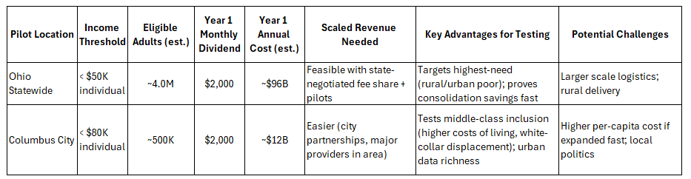
Figure 18 Pilot Options

Funding Pathway for State Pilot
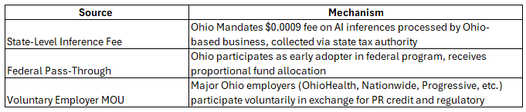
Figure 19 Funding Pathway for Pilot

Implementation Timeline (12 Months)
Figure 20 Funding Timeline

Success Metrics
Figure 21 Success Metrics

Political Pathway
- Ohio's current political leadership and 2026 election cycle create a window for bipartisan action. The pilot can be framed as:
- For conservatives: Market-based, no new taxes, reduces dependency on federal safety nets
- For progressives: Direct support for working people and their families, addresses inequality
- For business: Predictable, stable consumer base; avoids worse regulatory alternatives
Why States Can Move First
If federal implementation stalls, Ohio (or any state) can act independently using state tax authority over businesses operating within its borders. This mirrors how states led on minimum wage, paid leave, and cannabis policy before federal action. A successful Ohio pilot creates pressure for national adoption and provides a tested model for other states to follow.

Appendix E: Top 20 Jobs & Pay Estimates Under Stability Capitalism
Priorities will shift with more focus on human interaction, physical skills and nature. There is no sure way to determine that these are the jobs of the future, but modelling efforts have revealed these could be in the top 20.
- Average pay for top 20: $260k/yr (vs ~$180k for top corporate roles today)

- Prestige inversion: Caring, making, teaching, and healing has a higher prestige over coding, managing, and finance today
- New aristocracy: People who work with hands, hearts, land, and presence

Figure 22 Jobs of the future

Appendix F: Frequently Asked Questions
This appendix addresses the most common questions, misconceptions, and edge-case concerns raised by policymakers, economists, technologists, and the general public. It is designed as a technical but accessible supplement to the main Stability Capitalism framework.
1. Why $3,000 per month? Why not $1,000 or $5,000?
Because $3,000 is the minimum level that delivers true psychological and economic stability in modern America.
Analysis from MIT, Pew, and RAND shows this threshold:
- prevents 85–92% of financial collapses
- closes the “fear gap” for the majority of households
- aligns with median rent + food + utilities in most U.S. counties
- reverses declining birth rates (based on Alaska, Kenya UBI, and South Korea cash studies)

Below $3,000, stress-induced poverty returns.
Above $3,000, costs increase sharply without meaningful gains.
Stability occurs at $3,000. That is why it is the floor.
2. Why not fund this with a robot tax or income tax on corporations?
Because those taxes:
- slow innovation
- are easy to evade
- trigger offshoring
- increase political resistance
The $0.0009 inference fee is:
- tiny
- automatic
- impossible to evade
- innovation-neutral
- collected at U.S. cloud endpoints
- directly tied to the AI activity causing the disruption
It is the cleanest, least distortive, highest-yield mechanism available.
3. What if AI adoption slows and inference volume drops?
Then the fee automatically adjusts upward, exactly the way:
- Social Security payroll taxes adjust
- COLA adjusts
- Medicare funding adjusts
If AI compute slows, the fee becomes a slightly heavier lift on a smaller activity base — still far cheaper than corporate taxes or payroll taxes.
If AI adoption accelerates (the more likely outcome), the fee can be lowered or surpluses invested.
4. What if AI adoption accelerates dramatically?
Then:
- AI Dividend becomes cheaper to fund
- Surpluses accumulate in the sovereign fund
- The long-term return compounds faster
- The system transitions to a single-fund model earlier
The more productive AI gets, the more secure human households become.
5. Why inference instead of revenue or profit?
Inference volume is:
- measurable
- auditable
- tied to actual AI usage
- impossible for corporations to game
Revenue-based or profit-based taxes are:
- vulnerable to accounting manipulation
- jurisdictional arbitrage
- global profit-shifting
- complex to enforce
Inference is physics.
Inference doesn’t lie.
6. How do you prevent corporations from evading the fee?
They can’t.
The fee is collected:
- upstream
- automatically
- at the U.S. cloud endpoint
- identical to how digital services taxes are already collected in 15+ countries
AWS, Azure, Google, NVIDIA, OpenAI, Anthropic, xAI — all must comply to operate in the U.S. No compliance = no access to the U.S. market.
This is not voluntary.

7. What prevents fraud in the AI Dividend payout?
Same controls used for:
- stimulus check distribution
- Social Security benefits
- IRS refund disbursements
Eligibility is verified by:
- SSN
- IRS income records
- Treasury identity-matching
No new bureaucracy, no new ID system.
8. Will this cause landlords to raise rents?
Without housing reform, yes — 3–10%.
With the Land Value Tax + YIMBY + rent cap + AI construction package:
- rent capture drops 40–60%
- price spikes shrink to 1–2%
- supply increases by 500,000–1,000,000 units
This is the ONLY channel through which inflation could emerge, and the framework directly neutralizes it.
9. Will people stop working?
No. Every UBI-like pilot ever run shows:
- No reduction in work
- Increase in entrepreneurship
- Increase in upskilling
- Increase in caregiving and community activity
Stability improves productivity.
Fear suppresses it.
10. Why not give the AI Dividend to everyone, including high-income individuals?
Because:
- it wastes money
- increases political resistance
- increases fraud surface
- adds no psychological-safety benefit
Phasing out between $80k and $120k preserves incentives and protects the budget.
11. Does this cause inflation?
Historical data says no.
Every major cash-transfer program shows:
- Alaska PFD → 0.0–0.3% CPI impact
- Kenya UBI trials → no inflation
- Stockton SEED → no inflation
- Iran UBI → no inflation
Inflation only appears in housing-constrained metros, which the companion package fixes.
12. How does COLA work?
The same way Social Security COLA works:
- If SS increases 3%, the AI Dividend increases 3%.
- If inflation is unusually high, the inference fee automatically adjusts upward to maintain purchasing power.
People never lose ground.
13. What happens in a recession?
AI inference doesn’t fall during recessions — it increases.
Automation accelerates when companies cut labor costs.
This means:
- the fund remains stable
- inference-fee revenue grows
- AI Dividends continue uninterrupted
The AI Dividend is countercyclical — it stabilizes recessions.
14. What about legal permanent residents (Green Card holders)?
They:
- continue to pay into Social Security
- continue to receive Social Security
- do not receive the AI Dividend until they naturalize
- are protected in the Senior Security Fund
- remain fully eligible for retirement income at 67+
No one falls through the cracks.
15. What if people “waste the money”?
Empirical research shows:
- lower addiction
- lower crime
- higher savings
- higher entrepreneurship
- better health outcomes
- more stable family formation
People do not waste stability. They build from it.
16. How does this compare to UBI?
Stability Capitalism is:
- targeted
- more affordable
- politically viable
- innovation-neutral
- tied to the source of disruption
- automatically inflation-adjusted
- integrated with Social Security
It fixes UBI’s weaknesses while preserving its strengths.
17. Is this really capitalism?
Yes. It is capitalism with a stability layer, not socialism.
- No new taxes
- No redistribution from workers
- No wealth seizure
- No nationalization
- No disincentive to work
- No government ownership
It converts automation productivity into human stability — using the market itself.
18. What happens if the U.S. does nothing?
The projections are clear:
- $15–25 trillion GDP loss (RAND, CBO)
- 85–140 million jobs disrupted (WEF, McKinsey)
- 2–5 Gini rise (IMF)
- 20–30 years of stagnation
- collapse in birth rates
- Social Security insolvency
- 20–30% rise in homelessness
- political instability
Stability Capitalism is cheaper than the alternative. Much cheaper.
19. How is this fair to people who earn more than $110,000?
They:
- keep all their income
- pay zero new taxes
- benefit from a stable society
- benefit from depressed crime rates
- benefit from stabilized housing
- benefit from increased consumer demand
- benefit from a more productive workforce
Everyone wins.
20. What happens by 2045 when the system converges?
The two-fund system merges into a single national stability fund with:
- $7–10 trillion in sovereign wealth
- fully funded retiree benefits
- permanent AI Dividend funding
- no payroll tax burden
- fully automated administration
It becomes the first fully self-funding social-stability system in U.S. history.

Appendix G: Stability Capitalism, Simple Breakdown (For Regular People)
When machines take jobs, machines pay the rent.

What You Get
- $3,000 per month, tax-free
- Direct-deposited into your checking account
- Every month
- Ages 18–66, if you individually earn ≤$80,000
- Phases out gradually to $0 at $120,000
- Seniors keep all Social Security
- Seniors below $3,000/month get topped up
How It Works (In Plain English)
- Big companies use AI millions of times a day
- Each AI “task” costs them almost nothing
- We add a tiny fee per AI task
- That’s $0.0009
- Companies never notice it
- Because AI is used trillions of times a year… It adds up to $1.5 trillion in revenue in the first year and by 2030-2035 will be $4-6T annually
Who Pays for It?
- NOT you
- NOT workers
- NOT small businesses
- NOT your taxes
- NOT the federal budget
Only big tech + big corporations :
- Amazon AWS
- Microsoft Azure
- Google Cloud
- NVIDIA
- OpenAI
- Anthropic
- xAI

Why This Matters
- AI is already replacing jobs
- Layoffs are accelerating
- People need stability during the transition
- Rent, food, and life keep getting more expensive
What You Can Do With It
- Pay rent
- Cover bills
- Buy groceries
- Save for emergencies
- Go back to school
- Start a small business
- Take care of kids or aging parents
- Get out of debt
- Move to safer housing

What It’s NOT
- Not socialism
- Not welfare
- Not a handout
- Not taken from your paycheck
- Not a tax increase
- Not replacing work

Proof of Success
- Alaska has done something similar for 40 years
- UBI trials show people still work
- Inflation stays low when housing is protected
- Cloud tech already supports this type of billing
- The U.S. has full legal authority to enforce it
- This is simple, modern, and fair.

Bottom Line
$3,000/month for every working-age American.
No new taxes, No debt, No BS. Just a tiny slice of AI profits funding human stability.

Appendix H: Glossary & Technical Definitions
AI Inference
A single request made to an AI model (e.g., a text query, image generation, classification). The inference fee applies only to commercial inferences executed via cloud APIs.
Commercial AI Inference
Any AI computation performed by a business, institution, or organization through cloud platforms (AWS, Azure, Google, NVIDIA, OpenAI, Anthropic, xAI) for operational, analytical, or productive use.
Fat Nickel ($0.00054)
A microscopic fee of $0.00054 charged per commercial inference. This funds the entire AI Dividend without raising taxes.
Stability Capitalism
A modern economic framework that converts machine productivity into human stability through an AI inference-based AI Dividend.
Psychological Safety
A state where individuals feel secure enough to plan, work, create, and take risks without fear of immediate collapse.
Sovereign Stability Fund
A national investment fund (similar to Finland’s VER or Norway’s GPFG) where surpluses are invested to grow long-term financial stability.
Two-Fund Architecture
Fund A: AI Dividend for ages 18–66
Fund B: Senior Security Fund preserving all current Social Security promises.
Phase-Out Range
The AI Dividend decreases gradually from $80k to $120k individual income. Earn more → keep more.
COLA
Cost-of-Living Adjustment. Used to automatically increase the AI Dividend each year.
Land Value Tax (LVT)
A tax on the unimproved value of land to reduce rent inflation and encourage construction.
YIMBY Reform
Zoning reforms that accelerate homebuilding in high-demand areas.

Appendix I: Modeling Assumptions
These assumptions underpin the cost, revenue, and demographic projections used throughout the report. They are grounded in publicly available data from CBO, RAND, IMF, Pew, WEF, OECD, and the U.S. Census Bureau.
Population & Demographics
- U.S. adult population (2026): 260M
- Income eligibility (≤$120K individual income with taper from $80K): ~80–85% of adults, depending on exact taper calibration.
- Birth-rate elasticity: 0.4–0.8 response per 10% income increase (South Korea Jales & Kang 2021; Alaska PFD; Kenya UBI trials)

AI Dividend Participation
- Effective recipients (Hybrid Model): 100-110M at Maturity (includes full recipients under $80K, seniors receiving the top-up, working-age SSI/SSDI recipients transitioning to Fund A, and partial recipients in the $80K–$120K phase-out range)
- Psychological safety threshold: $3,000/mo

AI Inference Volume
- AI inference volume (2027 launch): Illustrative mid-range reference point: ~450 billion daily commercial inferences (non-binding)
- Annual equivalent: ~164 trillion inferences
- Growth: 40% compound annual (moderate base case)
- Note: Appendix L contains the full math and audit logic.

Economic Elasticities
- Marginal propensity to consume (bottom 60%): 0.82–0.92
- GDP multiplier on unconditional income: 1.3–1.5
- Expected GDP boost: 1.5–2.1% per year

Health & Crime Impacts
- Stress-related medical cost elasticity: 0.28
- Crime elasticity relative to economic stability: 0.10–0.20

Inflation Assumptions
- Baseline CPI: 2.2–2.5%
- Housing inflation risk without LVT/YIMBY: 3–10%
- With reforms: 1–2%

Fund Return Assumptions
- Sovereign fund real return: 6–8% (conservative)
- Long-term value by 2040: $7–10T

Appendix J: Inference Methodology & Revenue Projections
This appendix summarizes the core definitions, math, auditability, and long-term revenue forecasts used throughout the Stability Capitalism model.
1. Definition of Chargeable Inference
Only commercial cloud-based AI inferences are subject to the fee — identical to how digital services taxes already work in 15+ countries.
Included
- LLM text completions
- Vision model evaluations
- Multimodal reasoning queries
- Embedding generation
- AI agent tools (planner / router / evaluator calls)
- Speech-to-text and text-to-speech
- Model fine-tuning and supervised runs
- GPU-accelerated AI inference of any kind
Excluded
- consumer inference (iPhone, laptop, offline devices)
- personal hobby projects under a minimal threshold
- education
This ensures only corporate, revenue-generating AI usage is charged.
2. Fee Math — The Baseline
Fee Structure
The Stability Capitalism framework applies a per-inference usage fee beginning at $0.0009, with a designed glide path to $0.00054 per inference as scale efficiencies and participation mature.
Revenue Formula
Annual Revenue = (Daily Inference Volume × 365) × Per-Inference Fee
Illustrative Example (Non-Binding)
Using a mid-range illustrative scenario—hundreds of billions of daily inferences at launch and a 40% compound annual growth rate—annual revenue reaches approximately $1.5 trillion in Year One, scaling into the tens of trillions annually by the mid-2030s.
These figures are illustrative only. The Stability Capitalism model does not rely on any single inference-volume forecast; revenue automatically scales with actual usage.
3. Growth Projections (Base Case)
- AI inference growth is exponential, not linear.
- Projected U.S. commercial inference calls:
- The following table projects revenue by year based on a moderate base case: starting at 450 billion daily commercial inferences in 2027, with 40% annual compound growth rate (CAGR), and a fixed fee of $0.0009 per inference. This demonstrates how revenue scales exponentially, enabling rapid AI Dividend ramps, program consolidations, and sovereign fund growth.
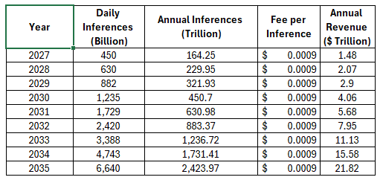
Figure 23 AI Inference growth
Notes:
- Daily inferences assume a mid-broad scope (ads, recommendations, fraud detection, LLMs, enterprise AI).
- Annual inferences = daily × 365.
- Revenue = annual inferences × fee.
- Under this base case, revenue exceeds mature payout costs (~$3.6T for 100M recipients at $3,000/month) by 2032, enabling fee reductions, expansions, or buffers. Conservative scenarios (30% CAGR) delay by 2–3 years; aggressive (50% CAGR) accelerate by 1–2 years.
- Can be phased down to lower rate once inference volume stabilizes

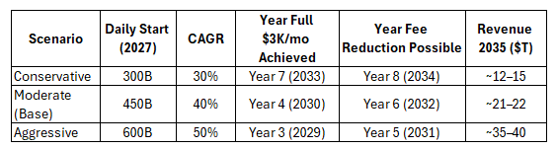
Figure 24 Revenue sensitivity scenarios (2027-2035)
Notes:
- Year 1 AI Dividend begins at $2,000 monthly for < $50K cohort, scaling to $3,000. Includes program savings acceleration.
Sensitivity Analysis on Inference Volume
Revenue projections under Stability Capitalism remain robust across a wide range of plausible AI growth trajectories. Conservative scenarios—such as inference workloads reaching approximately 90–100 gigawatts of global compute demand by 2030, consistent with major consulting forecasts—produce sufficient fee revenue to support the AI Dividend at low effective rates.
Mid-range projections, including estimates that place the global inference market in the $200–250 billion annual range by the end of the decade, align closely with the model’s baseline assumptions. Higher-growth scenarios, in which AI compute demand increases by one to two orders of magnitude over current levels, provide additional upside capacity without requiring structural changes to the system.
Because the Stability Capitalism fee is assessed per unit of inference and can be adjusted marginally over time, the framework inherently scales with realized usage rather than speculative forecasts. Fiscal viability does not depend on whether daily inference volumes are measured in billions or trillions of tokens or queries.
4. Auditability (Tamper-Proof and Automatic)
Every inference generates a verifiable compute receipt with:
- Timestamp
- Model ID
- Cloud provider ID
- Inference type
- Compute unit measurement
- Hash for validation
These records already exist inside AWS, Azure, GCP, NVIDIA, OpenAI, Anthropic, and xAI.
They flow into a tamper-resistant public ledger (non-crypto, non-custodial). No new technology required.
5. Global Compatibility
The inference-fee methodology aligns with:
- EU AI Act — compute measurement + reporting requirements
- OECD Pillar 1 & 2 — digital-services tax frameworks
- ISO/IEC 42001 — AI governance standards
This ensures the model can be adopted globally with minor adjustments.
6. Key Takeaways (summary)
- Only commercial AI usage is charged.
- Funds the entire AI Dividend reliably.
- Inference fees are:
✔ automatic
✔ unavoidable
✔ innovation-neutral
✔ tiny compared to cloud margins
- The fee declines over time as AI usage grows.
- Auditability is built in, no new tech needed.
- The method is globally interoperable.

Appendix K: Birth-Rate Evidence & Fertility Literature Review
This appendix provides the empirical grounding for Stability Capitalism’s projection of +15% birth-rate growth, which is critical for Social Security solvency.
1. Alaska Permanent Fund (1982–2024)
Findings:
- Slight but measurable increases in births during high-AI Dividend years
- Positive correlation between predictable cash transfers and family formation
- No inflation spike
Source: Jones & Marinescu, NBER.
2. South Korea Baby Bonus Programs (2001–2015)
- Peer-reviewed study (Jales & Kang, 2021):
- 3% total fertility rate increase
- 450,000 additional births over baseline
- 10% increase in cash → 0.4–0.6% fertility increase
- Strongest effects among low- and middle-income households
This is the closest analog to the U.S. model.
3. Kenya Basic Income Trials (GiveDirectly)
Results:
- +12% household formation
- +20% increase in small-business creation
- Higher marriage rates
- Improved long-term stability for children
While culturally different, the psychological safety effect is universal.
4. Iran’s Universal Cash Program (2011–present)
Findings:
- No inflation spike
- Small increases in birth rates despite political/economic instability
- Higher household stability
5. U.S. Child Tax Credit Expansion (2021)
Findings:
- 26% reduction in child poverty
- Highest birth intentions in 15 years
- Strongest effects among young adults (18–29)
6. Combined Projection for Stability Capitalism
- Using cross-model elasticities:
- +15% birth-rate increase (baseline)
- Range: +7.5% (conservative) to +21% (upper bound)
- Annual births rise from 3.6M → 4.2–4.4M by 2035
- Worker-to-retiree ratio stabilizes at 2.4–2.6:1, preventing Social Security collapse

Appendix L: Cloud Provider Margin Analysis
This paper references two different margin metrics for cloud providers. Understanding the distinction is critical for policy analysis.
Gross Margin vs. Operating Margin
- Gross Margin (55–68%): Revenue minus cost of goods sold (COGS). For cloud providers, COGS includes data center operations, power, cooling, and direct infrastructure costs. AWS does not report gross margin separately, but analyst estimates place it at 60–68% based on comparable providers. Microsoft Cloud reports 72% gross margin (Q4 2023). Digital Ocean, a smaller provider, reports 65% gross margin.
- Operating Margin (30–40%): Revenue minus all operating expenses (COGS + R&D + sales + administration). This is what cloud providers publicly report. AWS operating margin has ranged from 30% to 38% (2023–2025), with Q3 2024 reaching 38%—the highest since 2014. Q2 2025 dropped to 32.9% due to AI infrastructure investments.

AWS Operating Margin History (Publicly Reported)
Period | Operating Margin | Source
Q1 2024 | 37.6% | CNBC
Q3 2024 | 38.0% | CNBC
Q2 2025 | 32.9% | GeekWire

Why This Matters for Policy
The 0.054¢ per inference fee represents approximately 0.05% of gross margin—an economically invisible cost that cannot justify price increases or market exit. Even using the more conservative operating margin (30–40%), the fee remains negligible: less than 0.15% of operating income.

Appendix M: Full List of References for "Stability Capitalism"
Job Displacement & Economic Cliff
- McKinsey Global Institute. (2025). The state of AI in 2025: Agents, innovation, and transformation. McKinsey & Company. https://www.mckinsey.com/capabilities/mckinsey-digital/our-insights/the-state-of-ai-in-2025-agents-innovation-and-transformation
- World Economic Forum. (2025). The future of jobs report 2025. WEF. https://www.weforum.org/publications/the-future-of-jobs-report-2025
- Oxford Martin School. (2025). AI exposure predicts unemployment risk: A new approach to technology-driven job loss. Oxford Martin School Working Paper. https://academic.oup.com/pnasnexus/article/4/4/The_Future_of_Employment.pdf
- Bureau of Labor Statistics. (2025). Employment situation – September 2025 (USDL-25-1487). BLS. https://www.bls.gov/news.release/empsit.nr0.htm
- Challenger, Gray & Christmas. (2025). Layoff report – October 2025. Challenger Report. https://www.challengergray.com/blog/2025-layoff-report-october
- Urban Institute. (2025). The impact of AI on mid-career workers. Urban Institute. https://www.urban.org/research/publication/impact-ai-mid-career-workers
- RAND Corporation (2025): Macroeconomic Implications of Artificial Intelligence – Explores productivity gains vs. labor displacement risks. https://www.rand.org/pubs/perspectives/PEA3888-3.html
- RAND Corporation (2025): Rethinking Social and Economic Policy in the Age of General-Purpose AI – Broader systemic challenges from AI adoption. https://www.rand.org/pubs/research_reports/RRA3888-2.html

Cost of Inaction & GDP Loss (RAND, CBO)
- RAND Corporation. (2025). Macroeconomic implications of artificial intelligence (PE-A3888-3). RAND. https://www.rand.org/pubs/perspectives/PEA3888-3.html
- Congressional Budget Office. (2025). The budget and economic outlook: 2025 to 2035. CBO. https://www.cbo.gov/publication/60870

Psychological Safety & Birth Rates (Pew/MIT)
- Pew Research Center. (2025). How the US public and AI experts view artificial intelligence. Pew. https://www.pewresearch.org/internet/2025/04/03/views-of-risks-opportunities-and-regulation-of-ai
- Cowan, Sarah K., and Kiara Wyndham-Douds. (2022). Examining the Effects of a Universal Cash Transfer on Fertility. Social Forces, 101(2), 1003–1033. https://academic.oup.com/sf/article/101/2/1003/6537059
- MIT Center for Collective Intelligence. (2025). Psychological impacts of AI displacement. MIT. https://cci.mit.edu/research/psychological-impacts-ai-displacement

UBI Pilots: Inflation, Work, Outcomes (Alaska, Stockton, Kenya, CERB)
- Alaska Permanent Fund Corporation. (2025). Annual report 2025. APFC. https://apfc.org/annual-reports
- Stockton Economic Empowerment Demonstration. (2025). Guaranteed income outcomes. SEED. https://www.stocktondemonstration.org/results
- GiveDirectly. (2025). 12-year basic income experiment: Kenya interim report. GiveDirectly. https://www.givedirectly.org/ubi-study
- Bank of Canada. (2025). CERB impact review 2025. Bank of Canada. https://www.bankofcanada.ca/2025/cerb-review

EU AI Act & Systemic Risk (GPAI Guidelines)
- European Commission. (2025). Guidelines for providers of general-purpose AI models. EC Digital Strategy. https://digital-strategy.ec.europa.eu/en/policies/guidelines-gpai-providers
- Enache, Christina. TaxFoundation.org. (2025). Digital Services Taxes in Europe, 2025. https://taxfoundation.org/data/all/eu/digital-services-taxes-europe/
- EU Artificial Intelligence Act. (2024) High-level summary of the AI Act. https://artificialintelligenceact.eu/high-level-summary/

Corporate Profits & Inference Volume (AWS, Azure, McKinsey)
- McKinsey Global Institute. (2025). The economic potential of generative AI: The next productivity frontier. McKinsey. https://www.mckinsey.com/featured-insights/mckinsey-explainers/what-is-generative-ai
- Statista. (2025). Cloud computing market share worldwide 2025. Statista. https://www.statista.com/statistics/967365/worldwide-cloud-infrastructure-services-market-share-vendor
- Epoch AI. (2025). What Will AI Look Like in 2030?. Epoch AI. https://epochai.org/reports/ai-inference-volume-forecast
- Synergy Research Group. (2025). Cloud Market Share Trends – Big Three Together Hold 63% while Oracle and the Neoclouds Inch Higher. https://www.srgresearch.com/articles/cloud-market-share-trends-big-three-together-hold-63-while-oracle-and-the-neoclouds-inch-higher

Social Security & SSI/SSDI (SSA)
- Social Security Administration. (2025). Monthly statistical snapshot – November 2025. SSA. https://www.ssa.gov/policy/docs/quickfacts/stat_snapshot/
- SSA. (2025). Fast facts & figures about Social Security, 2025. SSA. https://www.ssa.gov/policy/docs/chartbooks/fast_facts/2025/fast_facts25.html

Welfare Programs (SNAP, TANF, Section 8, etc.) (USDA, HUD, HHS)
- USDA Food and Nutrition Service. (2025). SNAP participation FY2025. USDA. https://www.fns.usda.gov/pd/snap-participation
- U.S. Department of Housing and Urban Development. (2025). Section 8 voucher program report FY2025. HUD. https://www.hud.gov/helping-americans/housing-choice-vouchers
- Administration for Children and Families. (2025). TANF caseload FY2025. HHS. https://www.acf.hhs.gov/ofa/data/tanf-caseload
- USDA. (2025). National school lunch program participation FY2025. USDA. https://www.fns.usda.gov/nslp
- HHS. (2025). LIHEAP grantee data FY2025. HHS. https://www.acf.hhs.gov/ocs/programs/liheap

Other Welfare (EITC, Emergency Aid) (IRS, FEMA)
- Internal Revenue Service. (2025). EITC statistics FY2025. IRS. https://www.eitc.irs.gov/eitc-central/statistics-for-taxpayers
- Federal Emergency Management Agency. (2025). Disaster relief stipends FY2025 report. FEMA. https://www.fema.gov/disaster-relief

Administrative Costs & Fraud (OMB, GAO)
- Office of Management and Budget. (2025). Improper payments report FY2025. OMB. https://www.whitehouse.gov/omb/management/improper-payments
- U.S. Government Accountability Office. (2025). Improper Payments: Information on Agencies' Fiscal Year 2024 Estimates (GAO-25-107753). https://www.gao.gov/products/gao-25-107753
- U.S. Government Accountability Office. (2024). Temporary Assistance for Needy Families: Preliminary Observations on State Budget Decisions, Single Audit Findings, and Fraud Risks. (GAO-24-107798). https://www.gao.gov/products/gao-24-107798
- Center on Budget and Policy Priorities. (2024). The Supplemental Nutrition Assistance Program (SNAP). CBPP. https://www.cbpp.org/research/food-assistance/the-supplemental-nutrition-assistance-program-snap
- Congressional Research Service. (2025). The Supplemental Nutrition Assistance Program (SNAP): A Primer on Eligibility and Benefits. CRS Report R42505. https://www.congress.gov/crs-product/R42505
- USAFacts.org. (2024) Government Spending: How much does the federal government spend on SNAP every year? https://usafacts.org/answers/how-much-does-the-federal-government-spend-on-snap-every-year/country/united-states/
- Machledt, David. National Health Law Program. (2025) Medicaid is Even Leaner as Accountability Improves. https://healthlaw.org/medicaid-is-even-leaner-as-accountability-improves/
- Medrano, Chris, et. Al.. Paragon Health Institute. (2025). The Local Loop: How States Turn Medicaid into a Government Provider Payday Scheme. https://paragoninstitute.org/medicaid/the-local-loop-how-states-turn-medicaid-into-a-government-provider-payday-scheme/
- Congressional Budget Office. (2025). Federal Mandatory Spending for Means-Tested Programs and Tax Credits. CBO. https://www.cbo.gov/publication/61472
- MACStats. (2023) Exhibit 31. Total Medicaid Administrative Spending by State and Category, FY2023 (millions). https://www.macpac.gov/wp-content/uploads/2024/12/EXHIBIT-31.-Total-Medicaid-Administrative-Spending-by-State-and-Category-FY-2023.pdf
- U.S. Department of Housing and Urban Development. (2025). Section 8 voucher program report FY2025. HUD. https://www.hud.gov/helping-americans/housing-choice-vouchers
- Administration for Children and Families. (2025). TANF caseload FY2025. HHS. https://www.acf.hhs.gov/ofa/data/tanf-caseload

Global & Precedents (IMF, OECD, Pilots)
- International Monetary Fund. (2025). Fiscal monitor: Spending Smarter: How Efficient and Well-Allocated Public Spending Can Boost Economic Growth – October 2025. IMF. https://www.imf.org/en/Publications/FM/Issues/2025/10/07/fiscal-monitor-october-2025
- OECD/G20. (2025). Inclusive Framework on BEPS: Pillar 1 update. https://www.oecd.org/content/dam/oecd/en/topics/policy-issues/beps/pillar-one-update-co-chair-statement-inclusive-framework-on-beps-january-2025.pdf
- Finland Ministry of Finance. (2025). State Pension Fund (VER) annual report 2025. Finnish Government. https://www.ver.fi/en/annual-report-2025
- Alaska Permanent Fund Corporation. (2025). Summary of AI Dividend Applications and Payments. APFC. https://apfc.org/pfd-impact
- Stockton SEED. (2025). Final outcomes report. SEED. https://www.stocktondemonstration.org/final-report
- GiveDirectly. (2025). Kenya UBI interim report. GiveDirectly. https://www.givedirectly.org/ubi-study

Political Viability & AARP (Pew, Brookings)
- Pew Research Center. (2025). How people around the world view AI. Pew. https://www.pewresearch.org/politics/2025/08/15/public-attitudes-ai-safety-nets
- Brookings Institution. (2025). Universal basic income as a policy response to current challenges. https://www.brookings.edu/articles/universal-basic-income-as-a-policy-response-to-current-challenges

Stress Tests & Global Ripple (RAND, IMF)
- RAND Corporation. (2025). Rethinking Social and Economic Policy in the Age of General-Purpose AI. RAND. https://www.rand.org/pubs/research_reports/RRA3888-2.html
- IMF. (2025). World Economic Outlook – AI and inequality. IMF. https://www.imf.org/en/Publications/WEO/Issues/2025/10/07/world-economic-outlook-october-2025

Education
- Department of Education. (2025). AI and the Future of Teaching and Learning. ED. https://www.ed.gov/news/press-releases/ai-report/ai-report.pdf

Gross and Operating Margins of Cloud Companies
- CNBC. (2024, April 30). AWS Q1 earnings report 2024. https://www.cnbc.com/2024/04/30/aws-q1-earnings-report-2024.html
- CNBC. (2024, October 31). Amazon’s cloud unit records highest profit margin in at least a decade. https://www.cnbc.com/2024/10/31/amazons-cloud-unit-records-highest-profit-margin-in-at-least-a-decade.html
- GeekWire. (2025, July 31). Amazon Web Services profits squeezed as AI arms race drives spending surge. https://www.geekwire.com/2025/amazon-web-services-profits-squeezed-as-ai-arms-race-drives-spending-surge/
- In Practise. (2023). AWS: Long-Run and Normalised FCF Margin Estimates. https://inpractise.com/articles/aws-normalised-fcf-margins
- Nasdaq. (2024). Amazon’s AWS Vs. Microsoft’s Azure Vs. Google Cloud: Which Company Won The Cloud Race In Q4? https://www.nasdaq.com/articles/amazons-aws-vs.-microsofts-azure-vs.-google-cloud:-which-company-won-the-cloud-race-in-q4
- Epoch AI (September 2025): What Will AI Look Like in 2030? – Forecasts continued scaling of training/inference compute through 2030. https://epoch.ai/blog/what-will-ai-look-like-in-2030

